IFmove Wheel Dishing Adjustment

Both front and rear wheels of the IF Move require correct dishing to centre of the bike to ensure proper handling and control.
This adjustment can be performed the bicycle without removing the wheels.

Rear Wheel Instructions

The rear wheel requires the rim to be adjusted to the RHS of the bike (rim closer to the chain stay) by approximately 4mm from standard.
- Remove the tyre and tube
- Measure the distance from the side of the rim to the closest point of the chain stay. After adjustment the rim should be about 17mm away from the chainstay.
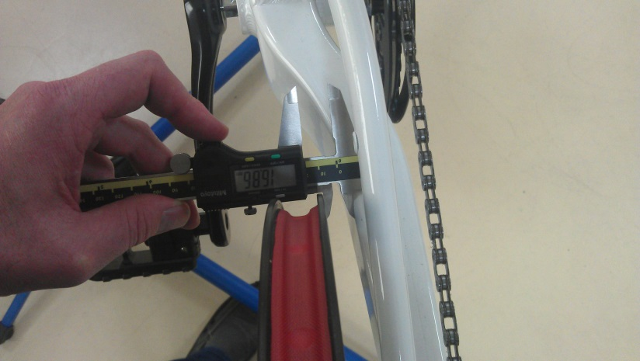
- Starting at the valve hole, loosen the non-drive spokes (LHS) by half a turn and then tighten the drive side (RHS) by half a turn as you go around the wheel. Repeat full revolutions until the rim is 4mm closer to the chain stay.
- If required use a zip tie around the seat stay as a reference to make sure the wheel is true. Adjust according.
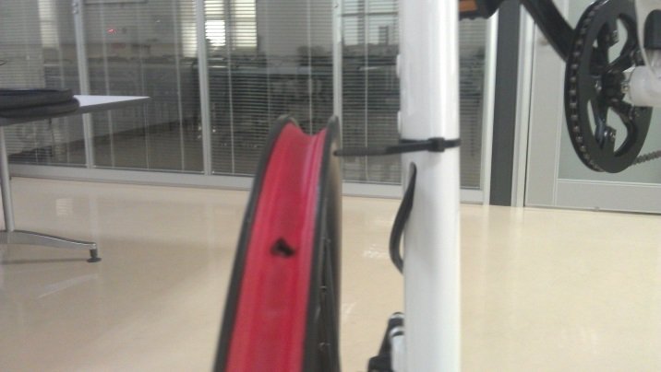

Front Wheel Instructions

The Front wheel requires the rim to be adjusted 1mm away from the fork blade RHS from standard.
- Remove the tyre and tube
- Measure the distance from the side of the rim and the closest point of the front fork – the final measurement should be 28mm between the rim and fork leg.
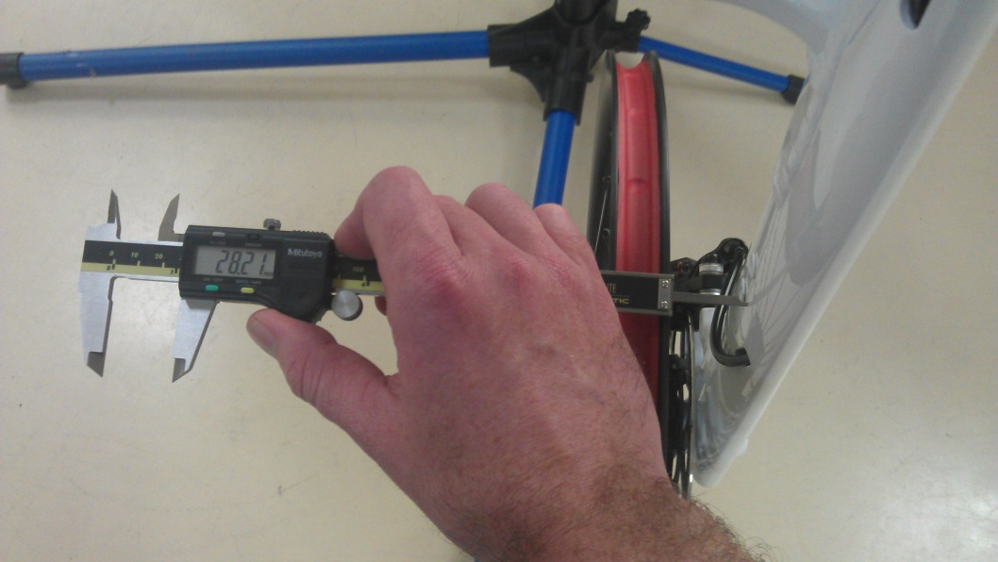
- Starting at the valve hole loosen the spokes on the brake side by half a turn and then tighten the non-brake side half a turn as you go around the wheel. On revolutions should be sufficient to adjust the rim across 1mm.
- If required use a zip tie around the fork leg as a reference to make sure the wheel is true. Adjust accordingly.
